Our Ref: _______________ Your Ref: ________________________ Date: __________________

Baptist Church

Baale Yaku Site Area, P. O. Box 644,

Ogbomoso, Oyo State. Tel. 07052425407

Email: [newsprinbaptistchurch@gmail.com](mailto:newsprinbaptistchurch@gmail.com)

Website: newspringbc.comze.com

NEW SPRING

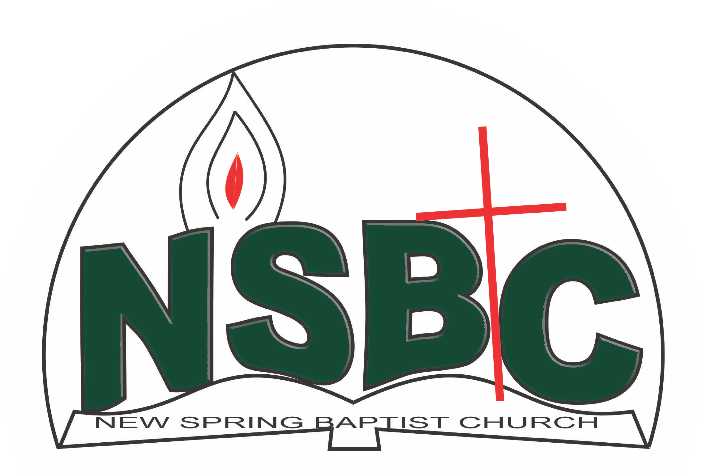

December 27, 2021

Dear Mr. Olusayo Okediji,

Nomination to Serve as an Officer and Worker in the Church in 2022.

Calvary greetings in the precious name of our Lord and Saviour Jesus Christ. It is our pleasure to inform you that, at the Church-in-Conference held on December 19, 2021, the Church ratified your nomination to serve in the following areas between January 1 and December 31, 2022

1. ChurchSecretary
2. Assistant Superintendent , Sunday School
3. Assistant Superintendent , Discipleship
4. Member, Membership Committee under the chairmanship of Mr. Johnson Olaniran
5. Member, History Committee under the chairmanship of Mr. Yemi Alamu
6. Member, Benevolence Committee under the chairmanship of Dn. Sunbo Olatubosun.
7. Member, Building Committee under the chairmanship of Dn. OmoOlorun Olupona
8. Member, Nominating Committee under the chairmanship of Dn. Ezekiel Ayinde
9. Member, Personnel Committee under the chairmanship of Mrs. Mobolape Adelakun
10. Member, Stewardship Committee under the chairmanship of Mrs. Nia olupona
11. Financial Secretary/Treasurer, Men’s Missionary Union (MMU)
12. Patron, Youth Fellowship
13. Member, Church Council Committee under the chairmanship of Rev’d Kayode Oke

Please refer to the table below for the key functions of each of these roles. Details can be found in the Church constitution. You are strongly encouraged to become familiar with the tasks as stated in the document. There will be an orientation of the Church workers on January 15, 2022 at 8:30 a.m. on the church premises. Please ensure you participate in this training. “Now it is required that those who have been given a trust must prove faithful. I Corinthians 4:2”. May God find you faithful in the task He has assigned to you.

| Domain | Key function of Office, Department or Committee |
| --- | --- |
| Church Secretary | To provide support to the Church Pastor in generating and storage of records of key Church activities and membership list for the effective ministry of the Church |
| Assistant Superintendent, Sunday School | To provide support to the Church Pastor in the teaching ministry of the Church to ensure that members and regular worshippers are well grounded in the Scriptures. |
| Assistant Superintendent, Discipleship | To provide support to the Church Pastor in the ministry of the Church to ensure that members and regular worshippers are well equipped for every good work. |
| Membership Committee | Responsible for the overall management of the membership of the Church. |
| Fin. Sec., MMU | Responsible for the accurate record and disbursement of all monies received by the MMU and to keep record of cash received by the MMU |
| Member, Church History Committee | The purpose of the committee is to document past and current key events in a systematic manner so that the evolution of the Church can be understood when her history is reviewed in the future. |
| Member, Benevolence Committee | The committee is responsible for the implementation of the benevolence policy of the Church. |
| Member, Building Committee | The purpose of the committee is to safeguard the interest of the Church in any building project the Church embarks upon |
| Member, Nominating Committee | The Nominating Committee shall coordinate the staffing of all Church leadership positions that are filled by volunteers. |
| Chairman, Personnel Committee | The committee is to assist the Church in matters relating to personnel administration. |
| Member, Stewardship Committee | The committee is responsible for the overall management of the Church’s fiscal policy. |
| Church Council member | The Church Council is the governing body of the Church whose membership, under the leadership of the Holy Spirit, holds one another mutually accountable with respect and love and sees to the smooth running of the Church. |
| Patron, Youth Fellowship | To provide support to the Church Pastor in counseling and equipping the youth of the Church for Christ-like life style and responsible adulthood. |

Thank you for accepting to serve in this Church.

Yours in His service

Revd Kayode Oke Blessed Agboola

Church Pastor Chairman, Nominating Committee

| Domain | Key function of Office, Department or Committee |
| --- | --- |
| Member, Beautification and Decoration Committee | The committee is responsible for the overall management of the Church’s fiscal policy. |
| Member,Drama Committee | The purpose of the committee is to coordinate both internal and external efforts in evangelism through drama. |
| Member, Church History Committee | The purpose of the committee is to document past and current key events in a systematic manner so that the evolution of the Church can be understood when her history is reviewed in the future |
| Ex-Officio, Church Council | The Church Council is the governing body of the Church whose membership, under the leadership of the Holy Spirit, holds one another mutually accountable with respect and love and sees to the smooth running of the Church. |

Thank you for accepting to serve in this Church.

Yours in His service

Olusayo Okediji Blessed Agboola

Church Secretary Chairman, Nominating Committee